**SCC204 Coursework** 38828634

**Design and Architecture**

1, UML Class Diagram

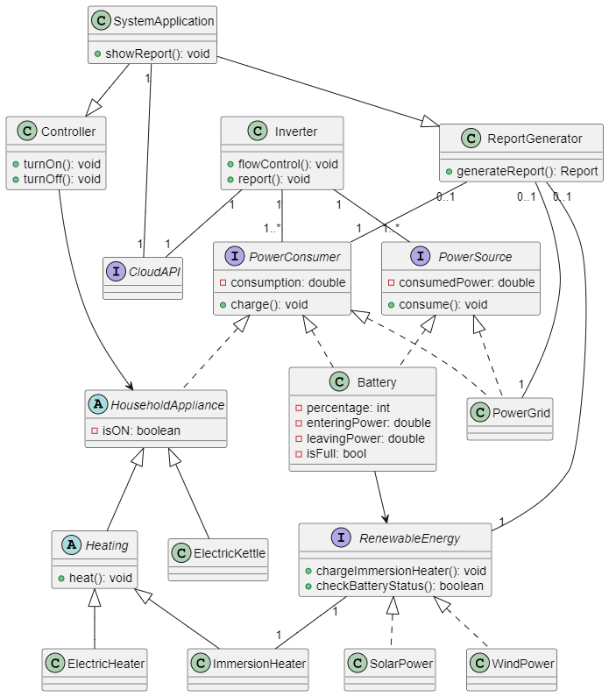

2, SOLID Principle

I made use of Single Responsibility Principle for Report Generator. I made a generic class called Report Generator, which can be extended by other elements so they can produce each report.

I also utilized Interface Segregation Principle for HouseholdAppliance. I divided household appliance to heating and other appliances because heating items (ElectricHeater and ImmersioHeater) are both able to heat some stuff, while other appliances cannot.

3, Assumptions

* I assumed that Renewable energy is the only source for charging battery, and it cannot be charged by national grid power.
* I assumed that appliance and heater can be controlled through household interface (it just turns them on and off).
* I assumed that national power grid is the only non-eco power resource available here.
* I assumed renewable energy can be used through the battery, except for immersion heater when the battery is full.
* I assumed system application allows users to interact with the household items.
* I assumed that inverter allows users to control the flow through cloud API.
* I assumed if other appliances are added to this system, they can be associated with HouseholdAppliance. If they have some sort of relation with heating, they can be associated with the Heating.

4, For the report, I chose to generate

* Eco Power Report that states how much power from renewable energy they used

…It’s important because it can make users feel like they are going something eco-friendly

* Non-Eco Power Report that states how much power from power grid they used

…It’s important for them to realize how much they are actually damaging the earth and encourage to use renewable energy instead

* Total Power Report that states how much power they used in one month

…Users can see how much energy they used compared to the other months so they can try to reduce the amount to the month that had least energy consumption

* Household Consumption Report that states which household item consumed power most

…Users can identify which household consumes a lot of power so they can actually consider buying a new one or avoid using it.